# Lab: Unit Testing

This document defines the lab for ["Java Advanced" course @ Software University](https://softuni.bg/modules/59/java-advanced).

# Part I: Unit Testing Basics

## Create Maven Project

Maven is build automation tool that takes care of dependencies for your project. Before you can make one, make sure that you enable the plugin in IntelliJ [File 🡪 Settings 🡪 Plugins 🡪 Maven]

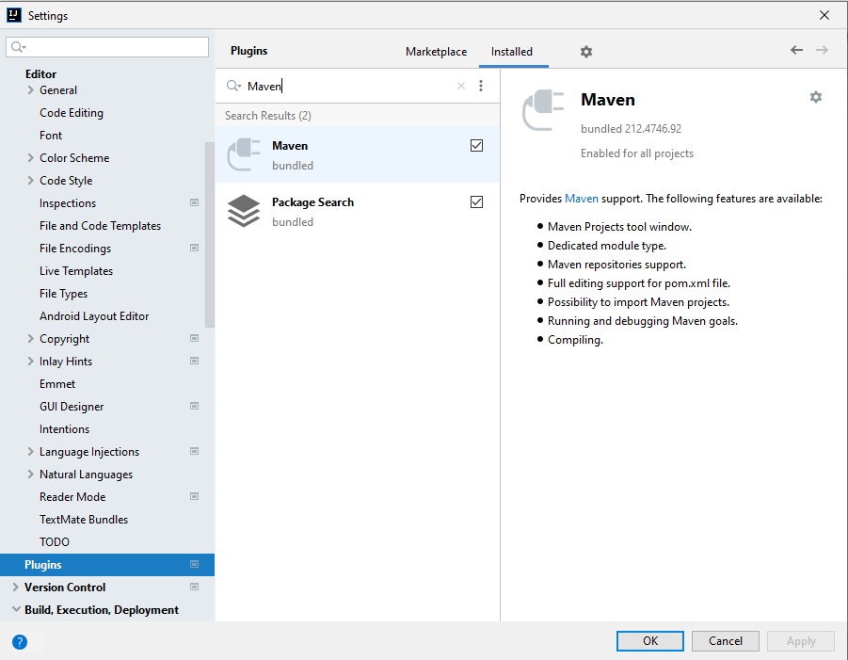

Now, you can create a Maven project.

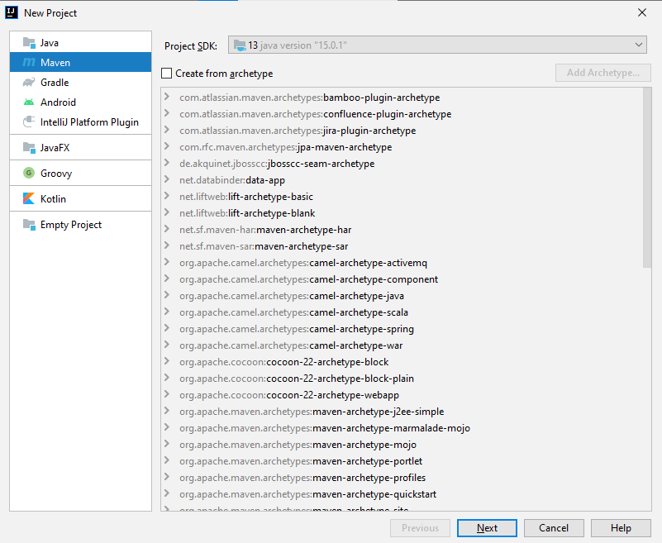

First, you give a name and location to your project. Group Id should be separated by dots, Artifact Id should be separated by hyphens:

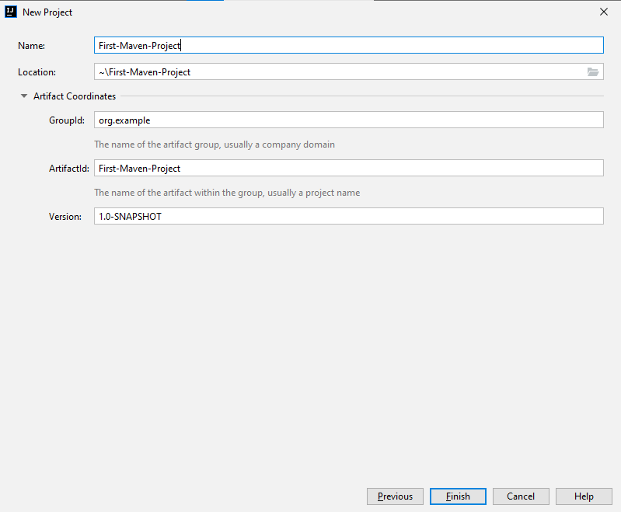

If everything is ok, you should see the following project structure:

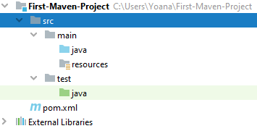

Copy the files provided and place them in a package inside src/main/java folder

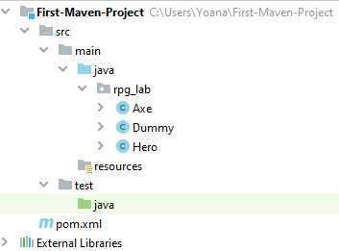

## Test Axe

In the test/java folder, create a package called rpg_tests.

Create a class AxeTests.

Create the following tests:

* Test if the weapon loses durability after each attack;
* Test attacking with a broken weapon.

### Solution

Create the new package rpg_tests and inside create the class AxeTests:

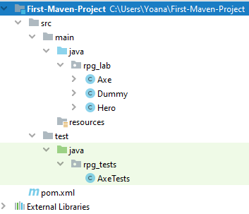

Inside the class create your first test:

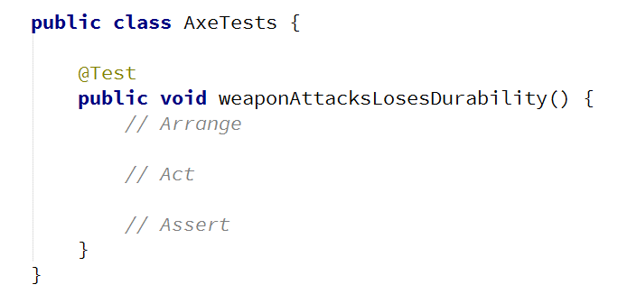

Arrange preconditions:

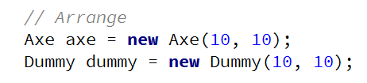

Execute tested behaviour:



Assert postconditions:

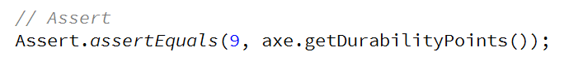

Create your second test method:

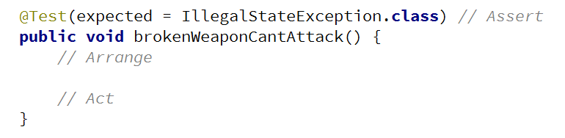

Arrange preconditions and test behaviour:

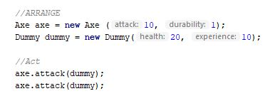

## Test Dummy

Create a class DummyTests.

Create the following tests:

* Dummy loses health if attacked.
* Dead Dummy throws an exception if attacked.
* Dead Dummy can give XP.
* Alive Dummy can't give XP.

### Hints

Follow the logic of the previous problem.

## Refactor Tests

Refactor the tests for Axe and Dummy classes.

Make sure that:

* **Names** of test methods are **descriptive.**
* You use **appropriate** **assertions** (assert equals vs assert true).
* You use **assertion** **messages.**
* There are **no magic numbers.**
* There is **no code duplication** (Don’t Repeat Yourself).

### Hints

Extract constants and private fields for Axe class:

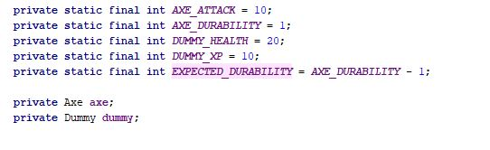

Create a method that executes **before each test:**

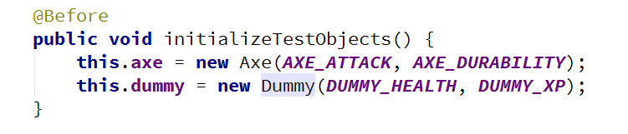

Make use of constants and private fields, as well as add assertion messages:

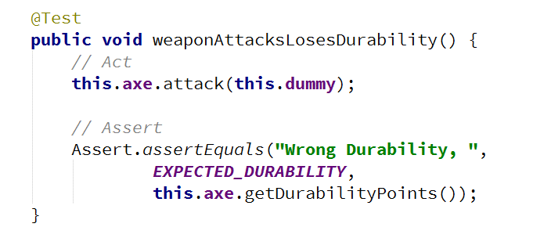

Follow the same logic for other test methods and TestDummy class.

# Part II: Dependencies

## Fake Axe and Dummy

Test if the hero gains XP when a target dies.

To do this, you need to:

* Make **Hero** class **testable** (use **Dependency Injection**).
* Introduce **Interfaces** for Axe and Dummy:
  + Interface Weapon
  + Interface Target

Create a fake Weapon and fake Dummy for the test.

### Hints

Create **Weapon** interface:

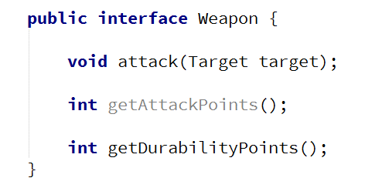

Create **Target** interface:

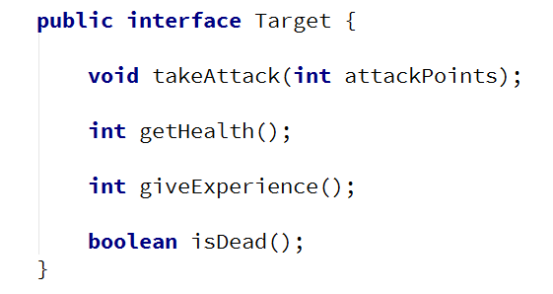

Implement interfaces :



Modify implementation methods to **make use of interfaces:**

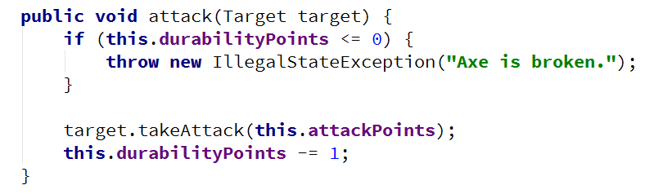

Modify both **Axe** and **Dummy** classes.

Use **Dependency Injection** for Hero class:

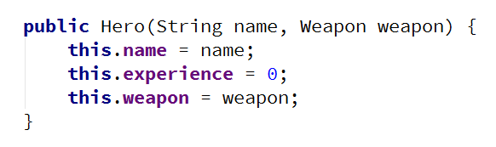

Create HeroTests class and test gaining XP functionality by faking Weapon and Target classes:

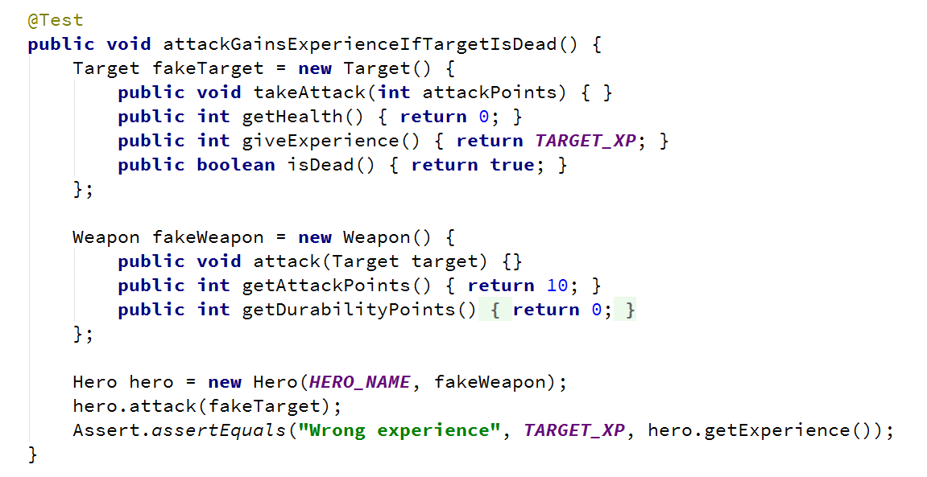

## Mocking

Include Mockito in the project dependencies, then:

1. Mock fakes from the previous problem.
2. Implement **Hero Inventory**, holding unequipped weapons:
   1. method - Iterable<Weapon> getInventory()
3. Implement Target giving random weapons upon death:
   1. field - private List<Weapon> possibleLoot
4. Test Hero killing a target getting loot in his inventory.

### Hints

Locate pom.xml.

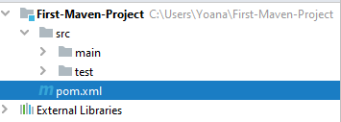

Add Mockito dependency.

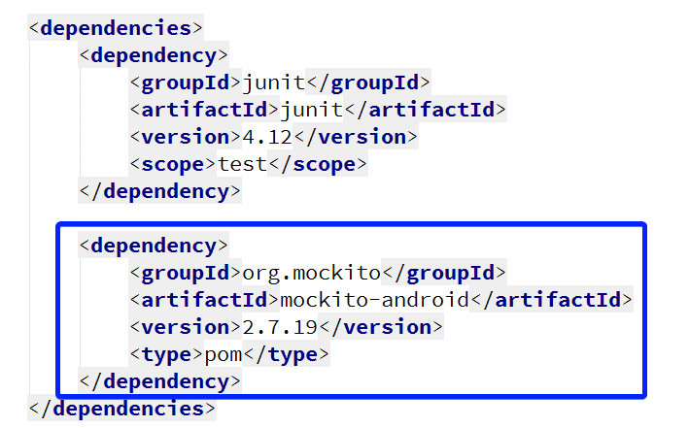

Go to HeroTests and refactor the code, making use of Mockito:

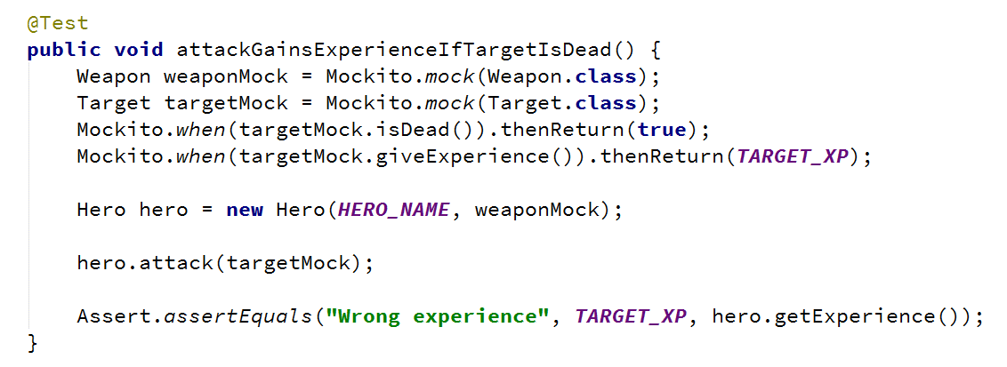

*Implement hero inventory and **Target** dropping loot functionalities.

*Test **Hero** getting loot upon killing a **Target.**